1.1 states of matter name: class: due date: 7.5
1. Which state of matter has a definite shape and volume? （ ）
A. Gas B. Liquid C. Solid

2. In which state of matter are particles arranged in a regular, fixed pattern? （ ）
A. Gas B. Liquid C. Solid

3.In a solid, the particles （ ）
A. Move freely B. Slide past each other
C.Vibration around fixed positions D. Are far apart from each other

4. Sodium chloride is a liquid at 900 °C.
How are the particles arranged and how do the particles move in sodium chloride at 900 °C? （ ）
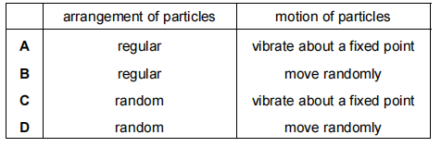

5.What happens to the volume of a gas when it is compressed? （ ）
A. Increases
B. Decreases
C. Stays the same
D. Becomes zero

6. A gas can be compressed easily because （ ）
A. Its particles are far apart B. Its particles are very small
C. Its particles have a fixed shape D. Its particles are arranged in a regular pattern

7. Which row describes the arrangement and motion of particles in a solid? （ ）
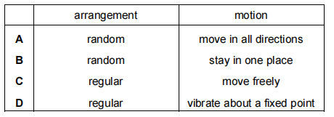

8. Which of the following describes the movement of particles in a liquid? （ ）
A. Vibrate around fixed positions
B. Move freely and randomly
C. Slide past each other
D. Do not move
9. In which state does 1 dm³ of methane contain the most particles? （ ）
A gas at 100 ℃
B gas at room temperature
C liquid
D solid

10.Which characteristic is unique to gases among the three common states of matter? （ ）
A. Definite volume but no definite shape
B. Particles closely packed in a regular pattern
C. Ability to expand and fill the entire container
D. Particles vibrating in fixed positions

11. Particles behave differently when in different physical states.
a.Solids have a fixed volume and a definite shape.
Gases have no fixed volume and take the shape of the container.
Describe the volume and shape of liquids.
......................................................................................................................................
......................................................................................................................................

12. Complete the table to show the volume, shape and fluidity of particles in each physical state.
state | Volume | Shape | Fluidity
solid
liquid | Fixed volume | Takes the shape of the container | Flow easily
gas

13. Complete the table to show the separation, arrangement and movement of particles in each physical state.
state | separation of particles | arrangement of particles | movement of particles
solid
liquid
gas

